Software Requirements Specification
Riebeeckstad Dierekliniek Booking & Client Management System
ITC327W — Work-Integrated Learning
Central University of Technology, Free State Diploma in Information Technology

Group Members
No | Group Members | Student Number
1 | NP Maluke | 222038366
2 | AT Rantoa | 222027706
3 | DM Skitla | 222093753
4 | SP Mokoena | 223056129
5 | O Maseko | 224120806
6 | TD Mokoena | 221045356
7 | KD Hlokoane | 221032445

1. Project Title

Riebeeckstad Dierekliniek Booking and Client Management System
An integrated Flutter mobile application, ASP.NET web application, and Supabase backend for online appointment booking, symptom submission, and clinic record management.

Problem Statement

The organisation currently uses telephonic bookings and the Microvet system, supported by a paper planner, to schedule and manage veterinary appointments. This results in no-shows, unscheduled walk-ins, and appointments occasionally being altered automatically within the system. The problem affects both clinic staff and clients because the urgency of a case is often unclear until the pet is already at the clinic, making it difficult for vets to prioritise cases and manage time between the practice's multiple veterinarians. An improved solution is needed to allow clients to book appointments online and to provide basic patient and symptom information in advance, so that clinic staff can better anticipate and prioritise incoming cases.

Purpose, Aim and Objectives

Purpose
This project exists to reduce Riebeeckstad Dierekliniek's reliance on telephonic bookings and give clinic staff earlier visibility of incoming cases, so that appointments can be scheduled and prioritised more effectively.

Aim
To design and develop an integrated mobile and web-based booking and client management system for Riebeeckstad Dierekliniek, using a Flutter mobile application, an ASP.NET web application, and a shared Supabase backend.

Objectives
- Allow pet owners to book appointments through a mobile application instead of relying solely on phone calls
- Allow pet owners to submit basic client, patient and symptom information at the time of booking
- Provide clinic staff with a web-based system to view, manage and update appointment bookings
- Enable role-based access so that vets and receptionists can view client and pet history, including treatment and payment records
- Reduce scheduling disruptions and administrative workload associated with the current telephonic process
- Establish an integrated, well-structured foundation (Flutter, ASP.NET and Supabase) that could support future enhancements such as automated reminders

Project Scope

The project scope covers the design and development of a Flutter mobile application for pet owners, an ASP.NET web application for clinic staff, and a shared Supabase backend, focused on appointment booking, symptom submission, and client/pet record management for Riebeeckstad Dierekliniek.
Cross-platform accessibility: The Flutter application will support mobile and desktop devices, while the ASP.NET web application will use responsive design to support both desktop and mobile web browsers.

Deliverables and Acceptance Criteria

Deliverables
- A Flutter mobile application allowing pet owners to register, log in, book appointments, and submit patient and symptom details
- An ASP.NET web application allowing clinic staff to log in, view and manage bookings, and access client/pet history
- A shared Supabase backend providing authentication, database and API services to both applications
- Integration between the applications through the shared Supabase backend.
- Testing of the system across supported mobile and desktop devices.

Acceptance Criteria
- A pet owner can successfully create a booking, including patient details and a description of symptoms, from the mobile application
- Clinic staff can view all current bookings and associated patient/symptom information from the web application
- Staff can reschedule or cancel a booking, and the change is reflected consistently across both platforms
- Only authenticated vet and reception accounts can access client and pet records

Exclusions, Constraints and Assumptions

Exclusions
- Direct integration with the existing Microvet system
- Online payment processing
- Automated SMS/WhatsApp reminders (identified as a possible future enhancement)
- Any form of automated medical diagnosis; the system will support triage-style urgency indication only, not clinical decision-making

Constraints
- The project must be completed within the ITC327W semester timeline
- Development is limited to the group's current knowledge of Flutter, ASP.NET and Supabase, supplemented by learning during the project
- No budget is available; only free-tier tools and services may be used
- Both applications depend on an internet connection to communicate with the Supabase backend.
- Cross-platform compatibility will require testing on different screen sizes and supported devices.

Assumptions

- Pet owners have access to a supported mobile or desktop device and an internet connection.
- Clinic staff have access to a desktop or mobile device with a modern web browser and internet connection.
- The stakeholder will remain available for feedback and confirmation of requirements.
- Supabase will provide the required backend services for the academic prototype.
- Users will have the appropriate permissions for the functions they need to perform.

Stakeholders and User Groups

Organisation
- Organisation name: Riebeeckstad Dierekliniek
- Type: Private veterinary clinic
- Location: 138 Mc Lean St, Riebeeckstad, Welkom, 9459
- Main activities: Consultations, surgeries and procedures, and general veterinary healthcare for pets

Primary Stakeholder
- Name and role: Dr. Nicolene Greyling, Partner (BVSc)
- Date of stakeholder interview: 21 August 2026

User Groups
- Pet owners (clients) — use the mobile application to book appointments and submit symptom information
- Receptionists — use the web application to view and manage bookings and client/pet records
- Veterinarians — use the web application to view bookings, assess urgency in advance, and access client/pet history including treatment and payment records

Current Process and Diagram

According to the stakeholder, the clinic's day-to-day activities consist mainly of consults and surgeries/procedures. Clients typically book by telephone, and although some walk-ins are accepted, the clinic prefers appointments to be scheduled in advance. Once a booking is made, it is captured on Microvet, a computer-based system that stores client information and the appointment book, with a physical planner kept as a backup. Client communication regarding appointments takes place via phone and email.
Problems experienced in the current process include no-shows, unscheduled walk-ins disrupting the planned schedule, the Microvet system occasionally shifting appointments automatically, and the true urgency of a case often only becoming clear once the pet is already at the clinic, since no symptom information is captured at the time of booking.
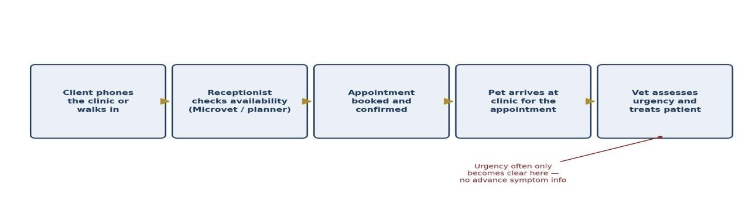
Figure 1: Current appointment booking process at Riebeeckstad Dierekliniek

Product Perspective

The proposed system is a new, self-contained solution and will not replace or directly integrate with the clinic's existing Microvet practice-management system in this phase; the two will operate in parallel, with staff continuing to use Microvet for internal record-keeping while the new system introduces an online booking channel for clients. The system consists of two connected front-ends — a Flutter mobile application for pet owners and an ASP.NET web application for clinic staff — sharing a single Supabase backend. This positions the product as a client-facing booking layer that feeds structured appointment and symptom information into a staff-facing management view, rather than a full replacement of the clinic's existing internal systems.

Main Flutter, ASP.NET and Supabase Functions

Flutter Mobile Application (Client-Facing)
- Client registration and login
- Appointment booking (date/time selection)
- Patient detail entry (name, breed, age)
- Symptom / reason-for-visit entry
- Viewing and cancelling a client's own upcoming appointments

ASP.NET Web Application (Staff-Facing)
- Staff login with role-based access (vet / receptionist)
- Viewing and managing all appointments
- Rescheduling or cancelling bookings
- Viewing client and pet history, including treatment and payment records

Supabase Backend
- Authentication for both client and staff accounts
- Central database for clients, patients, appointments and records
- API layer connecting the Flutter and ASP.NET applications to shared data
- Role-based access control at the database level

Functional Requirements

- FR1: The system shall allow a pet owner to register and log in to the mobile application.
- FR2: The system shall allow a pet owner to book an appointment by selecting an available date and time.
- FR3: The system shall allow a pet owner to enter patient details (patient name, breed, age) when booking an appointment.
- FR4: The system shall allow a pet owner to state the reason for the visit or symptoms when booking an appointment.
- FR5: The system shall allow a pet owner to enter and store their contact details (name, phone number, address).
- FR6: The system shall allow a pet owner view a list of all appointments and the appointment details.
- FR7: The system shall allow clinic staff (vets and receptionists) to log in to the web application using role based credentials.
- FR8: The system shall allow clinic staff to view a list of all current and upcoming appointments.
- FR9: The system shall allow clinic staff to reschedule or cancel an existing appointment.
- FR10: The system shall allow clinic staff to view client and pet history, including past treatment and payment records.
- FR11: The system shall restrict access to client and pet records to authenticated vet and receptionist accounts only.
- FR12: The system shall store all client, patient and appointment data in a shared Supabase backend accessible to both the mobile and web applications.

Non-Functional Requirements

- NFR1: Usability: The mobile application interface shall be simple and intuitive enough for pet owners with limited technical experience.
- NFR2: Performance: Booking submissions shall be confirmed within a reasonable time under normal network conditions (target: under 3 seconds).
- NFR3: Availability: The system should be accessible to clients at any time, and to staff at least during clinic operating hours.
- NFR4: Security: Client and pet records shall only be accessible to authenticated staff accounts, with rolebased permissions separating vet and reception access.
- NFR5: Reliability: Appointment data shall remain consistent between the mobile and web applications, without loss or duplication of bookings.
- NFR6: Maintainability: The system shall be structured so that future features (e.g. reminders) can be added without significant rework of the existing codebase.
- NFR7: Cross-Platform Compatibility: The system shall support access across mobile and desktop devices. The Flutter application shall be usable on supported mobile and desktop platforms, while the ASP.NET web application shall provide a responsive interface that is usable through modern web browsers on both mobile and desktop devices.
- NFR8: Responsive Design: The user interfaces shall adapt to different screen sizes and resolutions so that essential system functions remain accessible and usable on both mobile and desktop screens.

System Requirements

Mobile Application (Flutter)
- Compatible with Android and iOS smartphones
- The application must be usable on supported mobile devices and desktop devices, providing an appropriate user interface for different screen sizes and input methods.
- Requires an active internet connection to book appointments and sync data

Web Application (ASP.NET)
- Accessible via modern web browsers (e.g. Chrome, Edge, Firefox, Safari) on a desktop or laptop computer
- The ASP.NET web application shall be accessible through modern web browsers on both desktop and mobile devices. The web interface shall use a responsive design so that its functions and information remain usable on different screen sizes.
- Requires an active internet connection to access Supabase data

Backend (Supabase)
- Hosted on Supabase's cloud infrastructure (free tier for this academic prototype)
- Requires a stable internet connection for both applications to read/write data
- Supabase shall provide the shared backend services used by both the Flutter application and ASP.NET web application. These services shall include authentication, database storage and API services.

Integration Requirements

The Flutter mobile application, ASP.NET web application, and Supabase backend must operate as a single integrated solution:

Mobile-to-Backend Integration
The Flutter mobile application will connect to Supabase to allow pet owners to register, authenticate, create and manage their profiles, enter pet information, submit symptoms and create appointments.
When a pet owner creates an appointment through the mobile application, the appointment information will be stored in the shared Supabase database. The information may include the client's details, pet details, selected appointment date and time, and the reason for the visit or symptoms provided by the client.
The Flutter application will retrieve appointment information from Supabase when the client views or manages their bookings. All data submitted by the mobile application will therefore become available to the staff-facing web application through the same backend.

Web-to-Backend Integration
The ASP.NET web application will connect to the same Supabase backend used by the Flutter application. Clinic staff will authenticate through Supabase and, depending on their assigned role, will be able to access the information required for their responsibilities.
The web application will retrieve appointment, client and pet information from Supabase. Staff will be able to view, manage, reschedule or cancel appointments through the web application. Changes made by staff will be stored in Supabase and will subsequently be available to the Flutter application.

Authentication and Role-Based Access
Supabase Authentication will be used to authenticate users of both applications. Pet owners will authenticate through the Flutter mobile application, while receptionists and veterinarians will authenticate through the ASP.NET web application.
Role-based access control will determine which information and functions each user can access. Pet owners will only be able to access their own client, pet and appointment information. Receptionists and veterinarians will have access to the staff functions permitted for their respective roles.
Database-level access controls will be used to help prevent unauthorised users from accessing client and pet records.

API and Application Communication
The system shall provide access across mobile and desktop devices while maintaining the same backend integration architecture. The Flutter application and ASP.NET web application will use the shared Supabase backend regardless of the device from which the user accesses the system.
The integration structure is:

Flutter Mobile/Desktop Application → Supabase API/Services → Shared Supabase Database ← Supabase API/Services ← ASP.NET Responsive Web Application
This means that a booking created through the Flutter application on a mobile or desktop device will be stored in the shared Supabase database and made available to authorised staff through the ASP.NET web application. Similarly, changes made by staff through the web application on a desktop or mobile browser will be stored in Supabase and made available to the client application. The system shall maintain consistent data across supported devices and platforms.

Integration Consistency
The database structure and data definitions will be shared between the Flutter and ASP.NET development streams. Both applications must use the same database tables, fields and relationships for common information such as clients, pets and appointments.
Database changes will be documented and version-controlled to reduce the risk of the mobile and web development teams implementing incompatible data structures.
The system shall maintain consistency between platforms. For example, an appointment created through the mobile application must appear correctly in the staff web application, while an appointment cancelled or rescheduled by authorised staff must reflect the updated status when the client retrieves the appointment through the mobile application.

Integration Limitation
The mobile and web applications will not directly integrate with the clinic's existing Microvet system during this project phase. Microvet will continue to operate separately for the clinic's existing internal record-keeping. The proposed solution will therefore function as a new integrated booking and client-management layer using Flutter, ASP.NET and Supabase.
Direct Microvet integration, online payment processing and automated reminders are outside the current project scope and may be considered as future enhancements.

Requirements Prioritisation

The functional requirements listed in Section 12 have been prioritised using the MoSCoW method to guide development order.
Priority | Requirements | Reasoning
Must Have | FR1, FR2, FR3, FR4, FR5, FR6, FR7, FR11 | Core booking, login and data-storage functions without which the system cannot operate.
Should Have | FR8, FR9, FR10 | Important management functions that improve staff usability but are not required for a first working version.
Could Have | Viewing appointment history as a client (in-app) | Adds convenience for clients but is not essential to the core booking workflow.
Won't Have (this phase) | Automated reminders, Microvet integration, online payments | Excluded from the current project scope; may be considered for future phases.

Appendices Containing Stakeholder Evidence

Appendix A: Stakeholder Interview Evidence
The completed Stakeholder Interview Preparation form, containing responses recorded during the interview with Dr. Nicolene Greyling (Partner, Riebeeckstad Dierekliniek) on 21 August 2026, is attached as supporting evidence for the requirements and needs documented in this SRS. The original signed form is retained by the group and available on request.
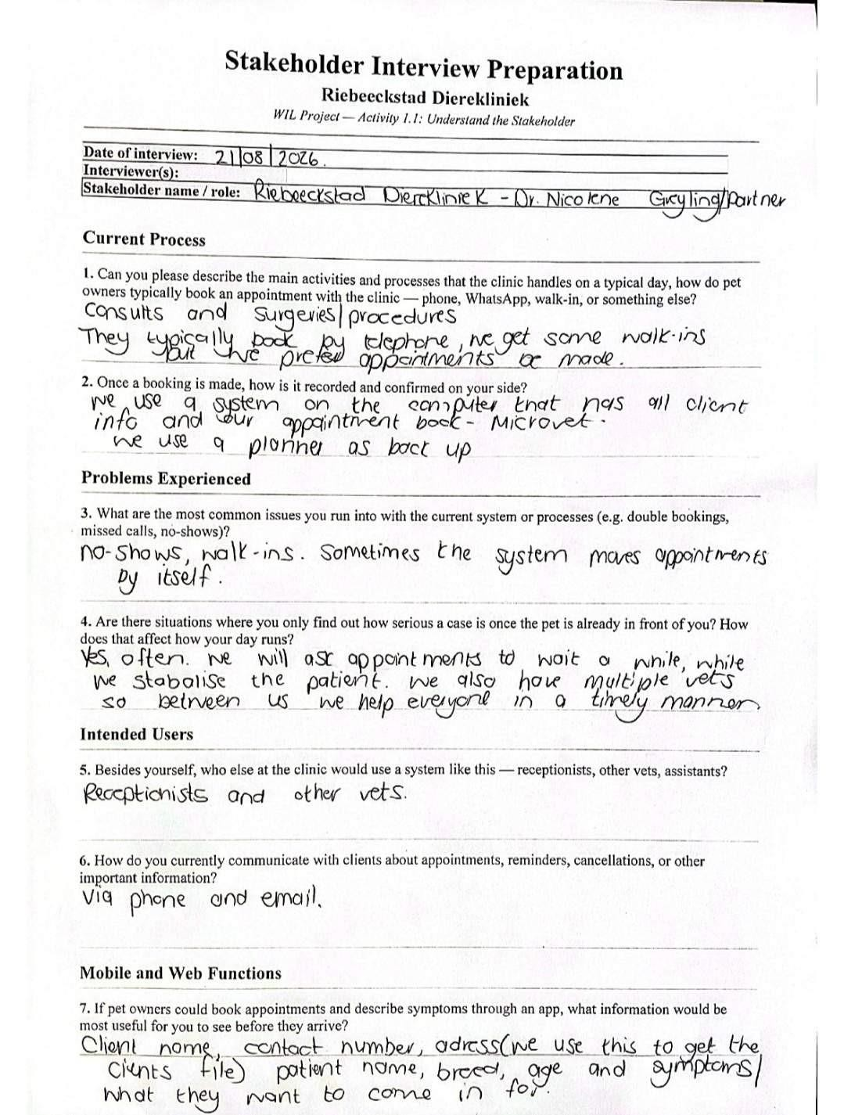

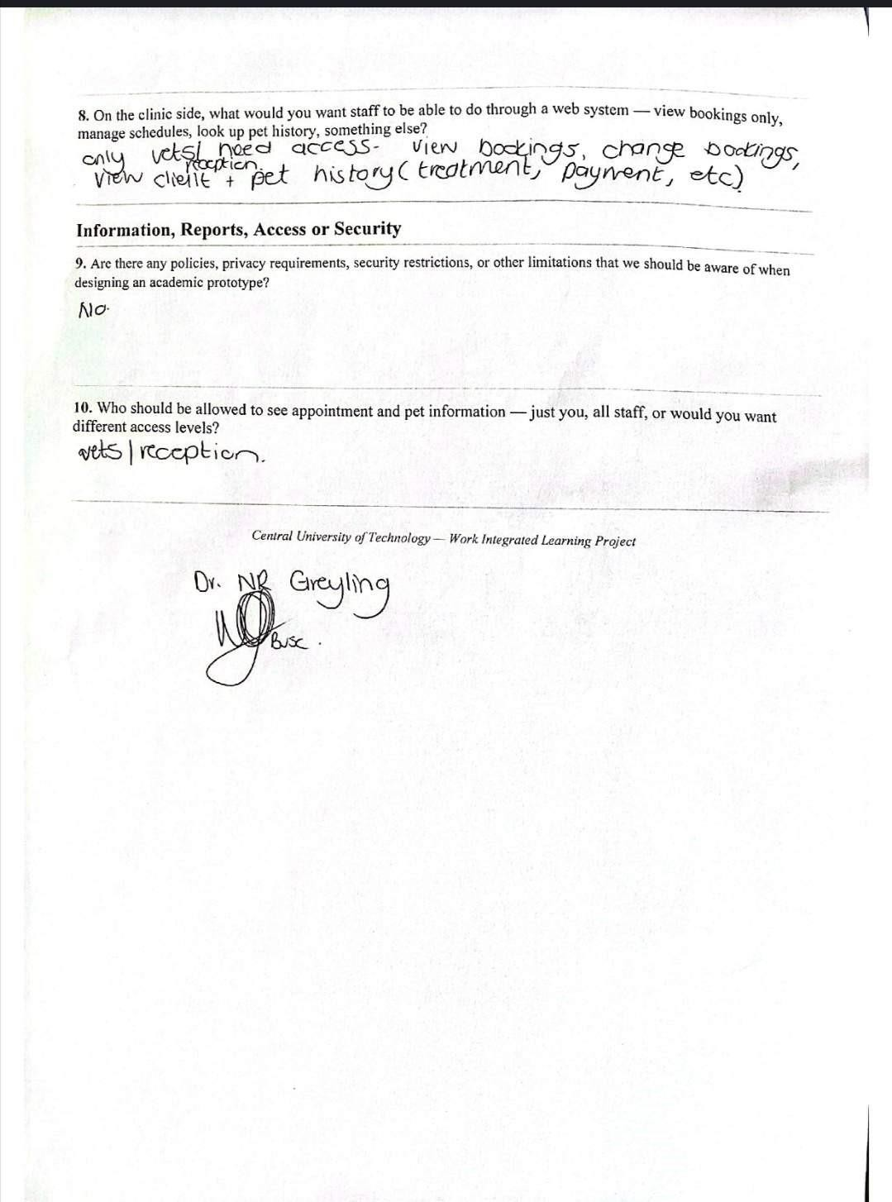

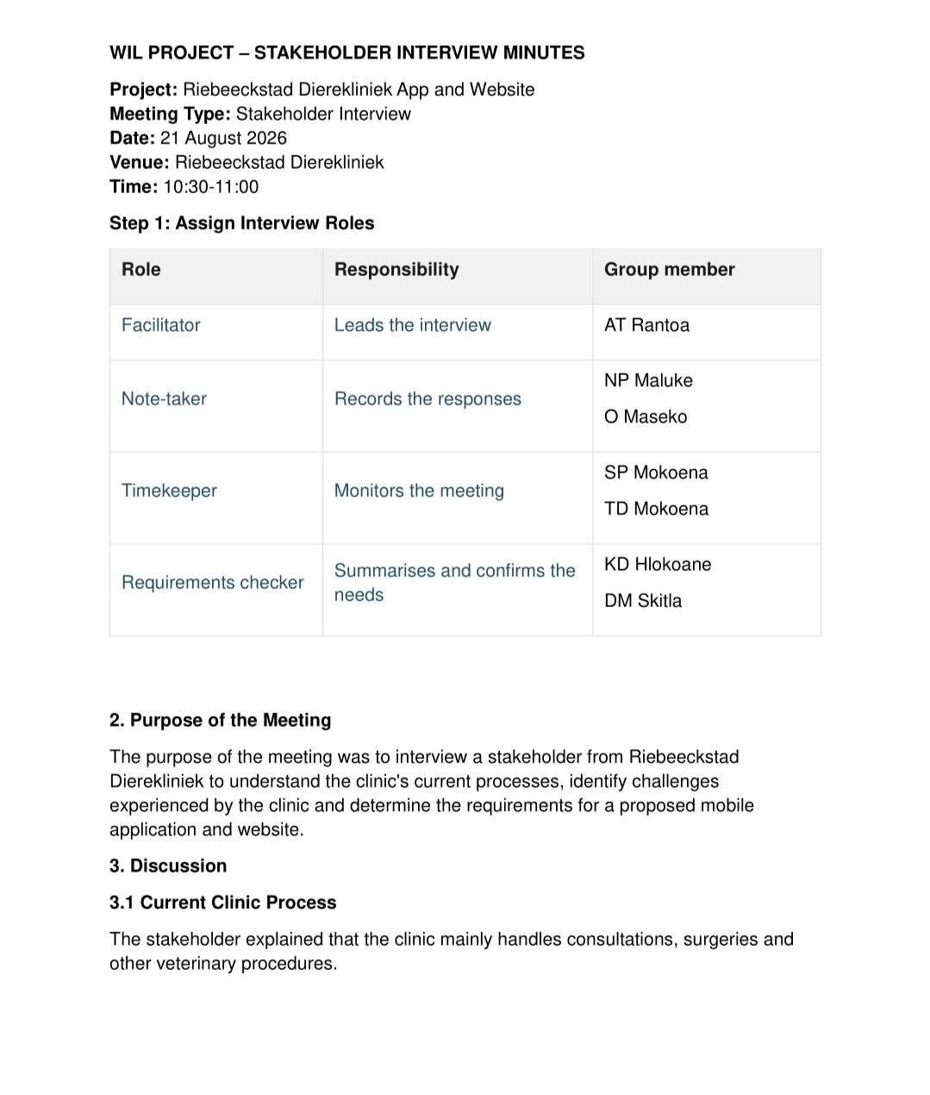

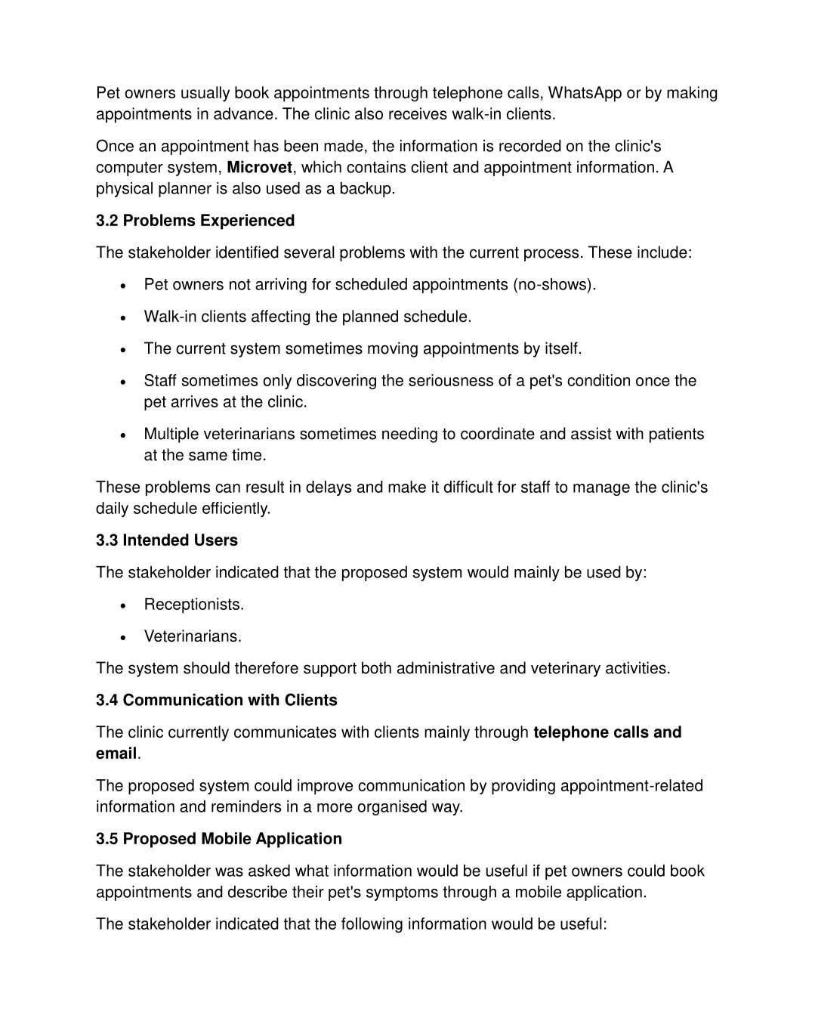

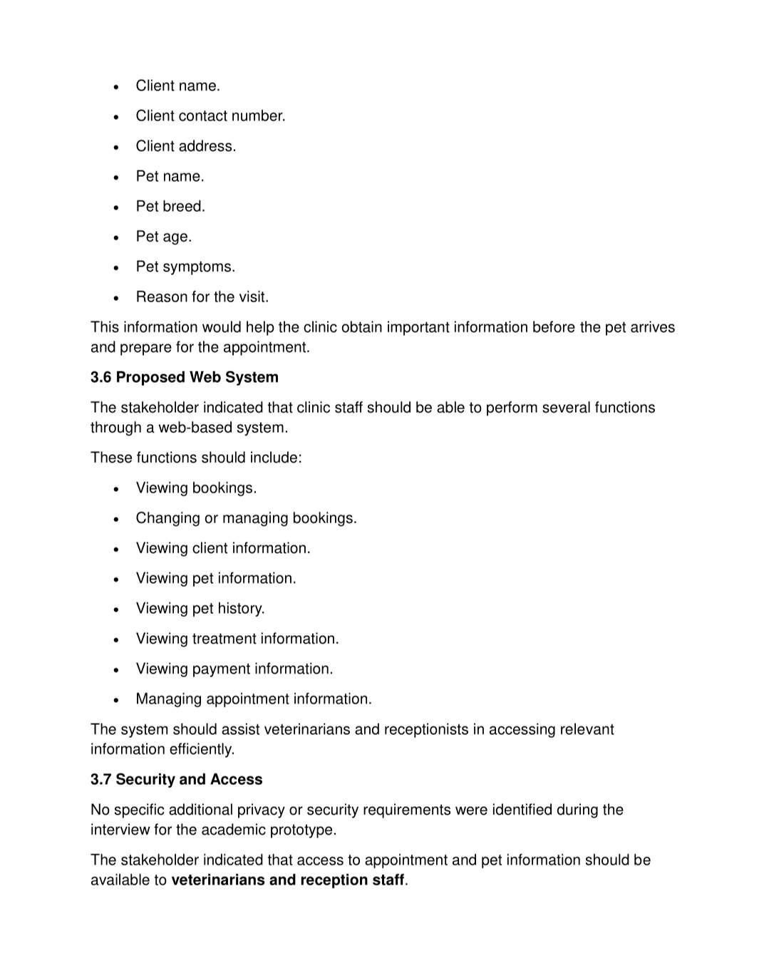

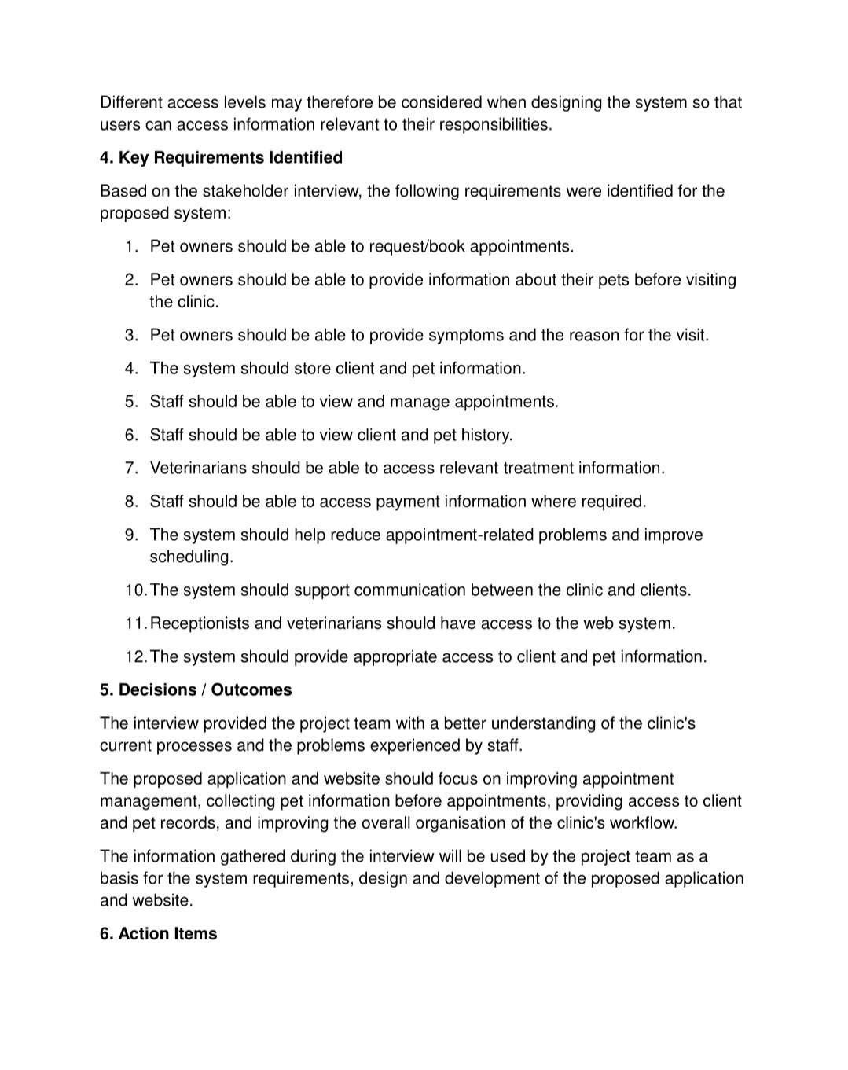

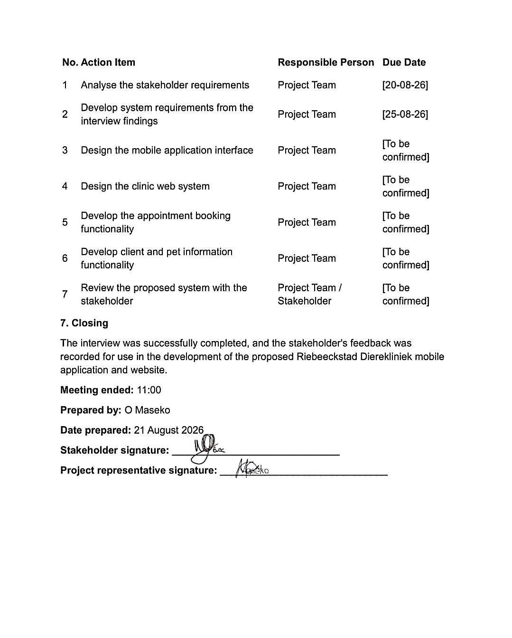

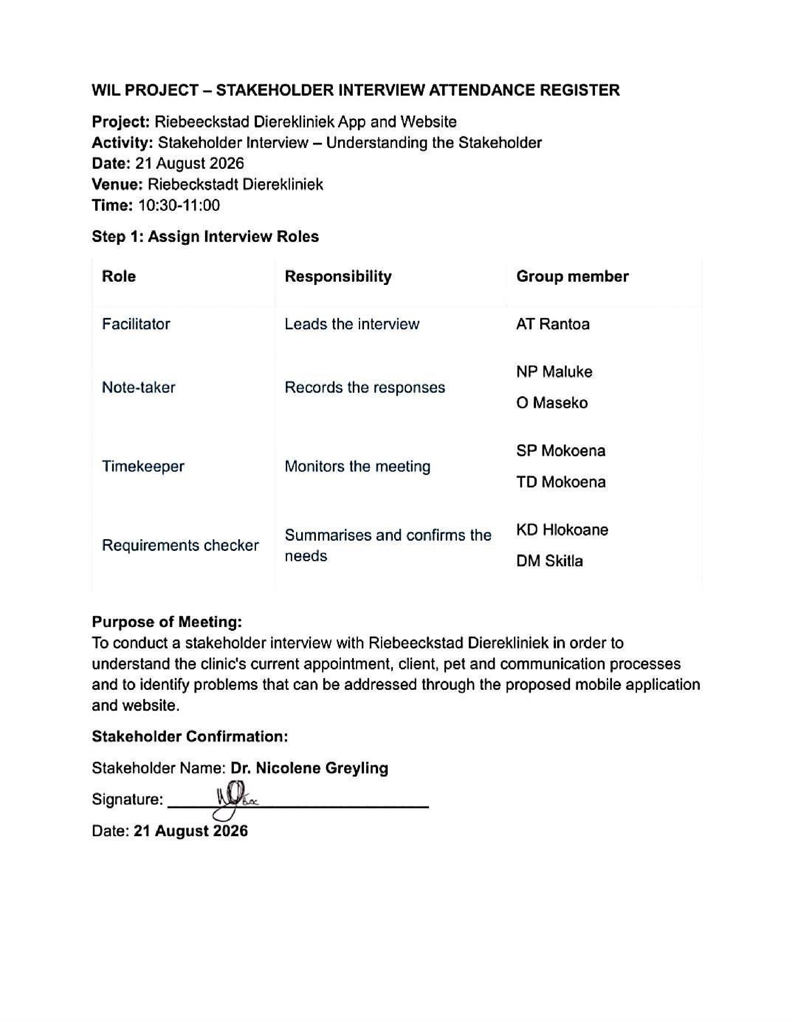

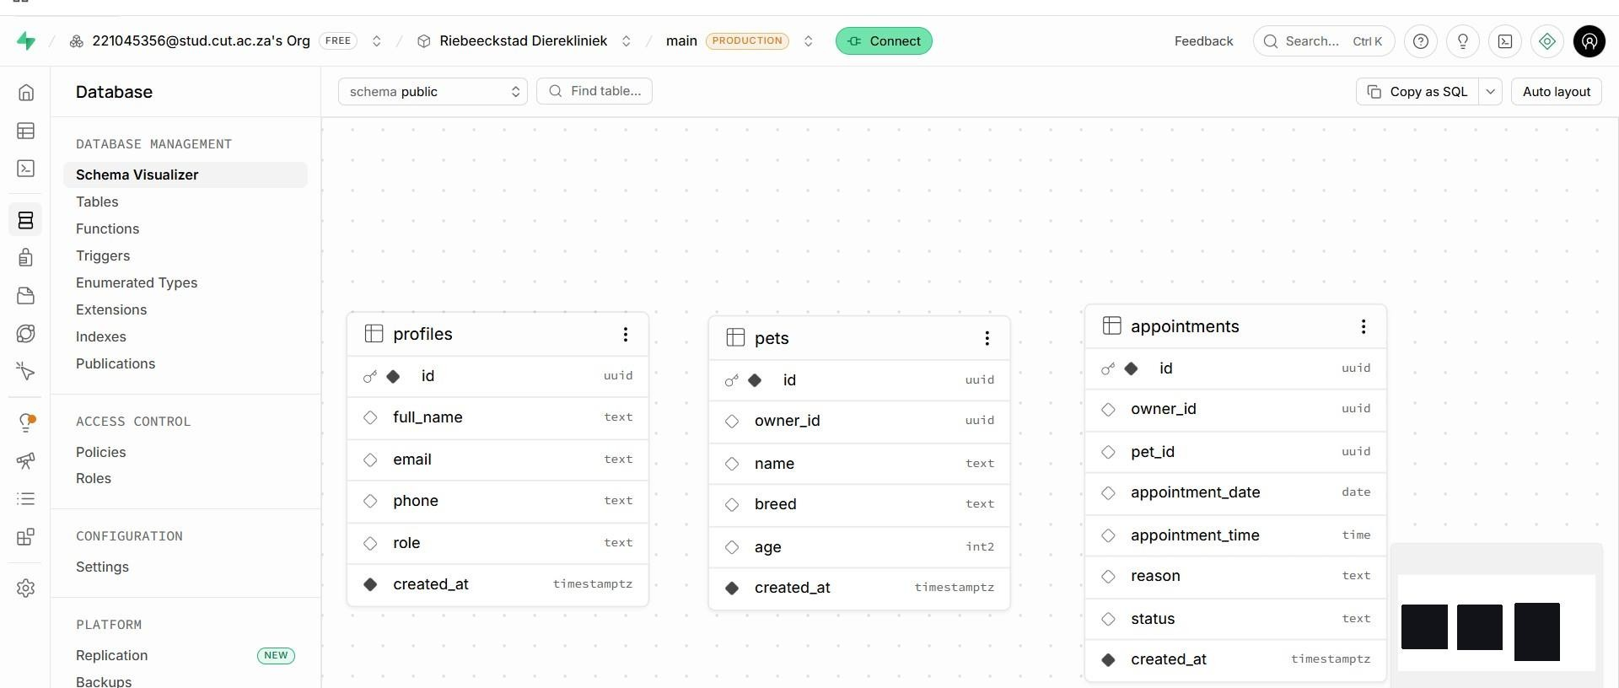

Appendix B: SupaBase Database SetUp

Supabase Link: https://qgzrolkkggcmfxoycadj.supabase.co/rest/v1/
GitHub Link: https://github.com/Tseko024/Riebeeckstad_Dierekliniek-.git

Feasibility Areas

Your assessment specifically requires these six areas: technical, operational, economic, schedule, legal, and ethical feasibility.

Technical Feasibility
The proposed system is technically feasible because it will use technologies that are suitable for the required solution: Flutter for the mobile application, ASP.NET for the web application, and Supabase for authentication, database and API services. Both applications will connect to the same Supabase backend, allowing them to share client, pet and appointment information.
The main technical challenge is ensuring that the Flutter and ASP.NET applications use the same database structure and correctly synchronise appointment information. The development team will therefore need to coordinate database changes, test the API connections and perform end-to-end testing between the mobile application, backend and web application.

Operational Feasibility
The proposed system is operationally feasible because it addresses the current booking and appointment-management problems identified at Riebeeckstad Dierekliniek.
Pet owners will be able to book appointments and submit basic patient and symptom information through the mobile application. Receptionists and veterinarians will be able to use the web application to view and manage appointments and access relevant client and pet information.
The system is intended to support the clinic's existing activities rather than immediately replace Microvet. Therefore, staff can continue using Microvet for existing internal record-keeping while the new system provides the online booking and management functionality.

Economic Feasibility
The project is economically feasible for the planned academic prototype because the group does not have a project budget and intends to use free-tier tools and services.
The main resources required are the group's existing development computers, internet access, development software, Flutter, ASP.NET and Supabase. Using free or already available resources reduces the financial requirements of developing the prototype.
However, additional costs may need to be considered if the system were deployed as a full production solution in the future.

Schedule Feasibility
The project is schedule-feasible provided that the group maintains a realistic scope and prioritises the most important requirements.
The project must be completed within the ITC327W semester timeline. Development therefore focuses on the core booking, client/pet information, staff management and Flutter–Supabase– ASP.NET integration requirements.
Features such as automated reminders, online payments and direct Microvet integration have been excluded from the current phase to prevent the project from becoming too large to complete within the available time.

Legal Feasibility
The system will handle client and pet information, so information must be protected from unauthorised access. Authentication and role-based access controls will be required to restrict access to information according to the user's role.
The project repository must also be managed responsibly. Passwords, API keys and confidential stakeholder information must not be uploaded to GitHub.
The assessment specifically states that legal feasibility must consider privacy, access, data and information-handling considerations.

Ethical Feasibility
The proposed system is ethically feasible because its purpose is to improve appointment management and provide staff with earlier access to information supplied by clients.
The system will not provide automated medical diagnosis. Symptom information may be used to provide a triage-style indication of urgency, but clinical decisions will remain the responsibility of qualified veterinary staff.
The project will also avoid unnecessary collection or exposure of stakeholder and client information and will ensure that users only receive access to information appropriate to their role.

19.Project Risk Register

ID | Risk | Category | Likelihood | Impact | Level
R1 | Flutter and ASP.NET applications may use incompatible database structures or fields | Technical | Low | High | High
R2 | Limited Supabase experience may delay backend integration | Technical | Medium | High | High
R3 | The group may not have enough time to complete all planned functionality | Schedule | Medium | High | High
R4 | Stakeholder feedback may be delayed or requirements may change late in development | Stakeholder | Medium | High | Medium
R5 | Different group members may implement conflicting or inconsistent changes | Project  Management
R6 | Additional requested features may cause the project scope to expand beyond the available time | Scope

20.SWOT Analysis

Strengths Weaknesses

Opportunities Threats

PHASE 2

Identify the Main System Components

Component | Main Responsibilities
Flutter Mobile Application | Provides the client-facing booking functionality. Pet owners can register, log in, book appointments, enter pet and symptom information, and view/manage bookings
ASP.NET Web Application | Provides the clinic staff interface. Veterinarians and receptionists can view and manage appointments and access client and pet records according to their roles.
Supabase Authentication | Manages user registration, login and authenticated access. It supports role-based access for clients, veterinarians and receptionists.
Supabase Database | It stores client information, pet/patient records, appointments, user information and treatment records used by both applications

Identify Who Uses Each Application
The user groups below are based on the stakeholder requirements for the Riebeeckstad Dierekliniek system.
User/Role | Uses Flutter | Uses ASP.NET | Main Purpose
Pet Owner/Clients | Yes | No | Register/login, book appointments, submit pet details and symptoms, and view/manage bookings
Receptionists | No | Yes | View and manage bookings and access client/pet information according to their role
Veterinarians | No | Yes | View appointments, assess urgency, access client/pet history and view relevant treatment information

Identify the Responsibility of Each Component
Component | Main Responsibilities
Flutter | Client interface; registration/login; appointment date and time selection; patient details; symptoms/reason-for-visit entry; viewing, rescheduling and cancelling bookings; access from supported mobile devices and computers
ASP.NET | Staff interface; staff login; appointment management; client and pet records; role-based access; viewing, updating, rescheduling and cancelling bookings; responsive web access
Supabase Authentication | Authenticate users, manage login and support role-based access for clients, veterinarians and receptionists.
Supabase Database | Store shared client, pet, appointment, user, treatment and payment information for both applications
Supabase Storage | Store and retrieve uploaded files or documents where required

Identify the Main Data Flows
From | To | Information Exchanged
Pet Owner / Client | Flutter | Login details, client details, pet details, appointment request and symptoms/reason for visit
Flutter | Supabase Authentication | Registration and login authentication information
Flutter | Supabase Database | Client, pet, appointment and symptom information
Supabase Database | Flutter | Available appointments, booking status and permitted client booking information
Clinic Staff | ASP.NET | Login details and appointment management requests
ASP.NET | Supabase Authentication | Staff authentication and role information
ASP.NET | Supabase Database | Appointment creation, updates, rescheduling, cancellation and record requests
Supabase Database | ASP.NET | Current/upcoming appointments, client/pet history and permitted treatment information
Flutter / ASP.NET | Supabase Storage | Upload or retrieve authorised files/documents where required
Supabase | Optional Email/WhatsApp Service | Future notifications or appointment reminders; outside the current core scope

- System Architecture Design

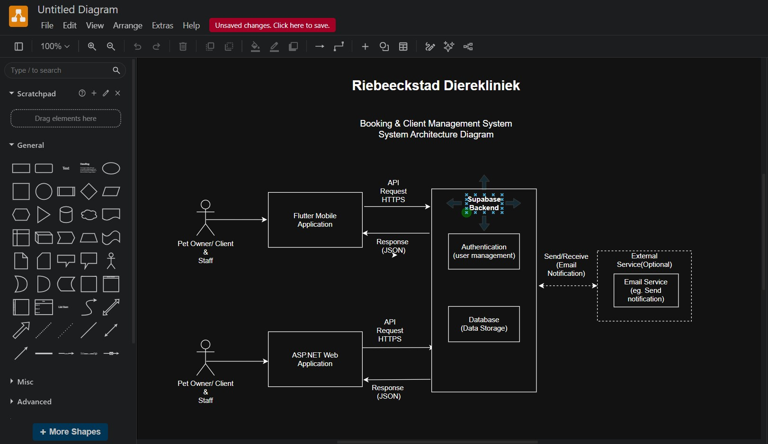
Figure 1: System Architecture Diagram
Pet owners use the Flutter mobile application to register, manage their pets, and book appointments. Clinic staff, including veterinarians and receptionists, use the ASP.NET web application to view and manage appointments and client and pet information according to their roles. Both applications communicate with the shared Supabase backend, which provides authentication, database storage, and file storage. This allows information such as bookings and pet details to be shared between the mobile and web applications, creating one integrated system.

- UML Design

Use Case Diagram
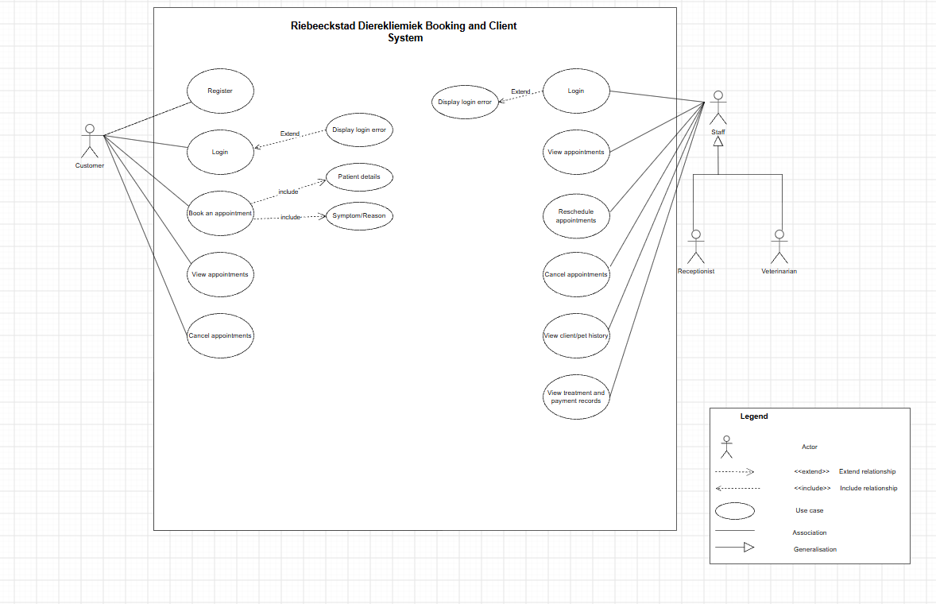
Figure 2: Use Case Diagram
Shows how the different users of the Riebeeckstad Dierekliniek system interact with the proposed system and what functions they can perform. It consists of two actors, with the customer(pet owner) as the primary actor and the staff as the secondary actor. Customer can register and login, provide patient and symptoms, book, view and cancel appointments. Staff includes receptionists and veterinarians. They can login and view appointments and reschedule or cancel appointments, view client and pet history and access treatment and payment records.

Sequence Diagram for Flutter Application
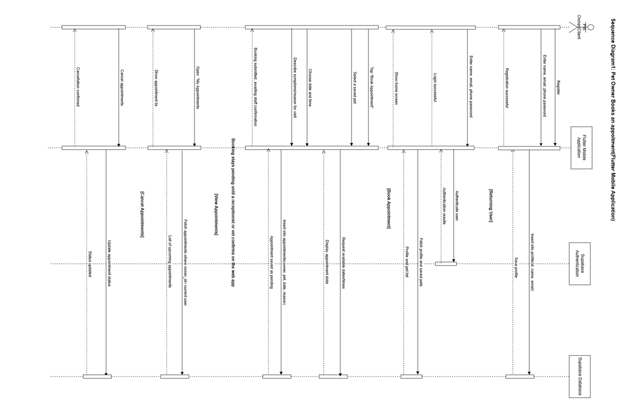
Figure 3: Flutter Sequence Diagram
This sequence diagram illustrates how a customer interacts with the Flutter application to register, log in, book an appointment, view their appointments, and cancel an appointment. The application communicates with Supabase Authentication to verify the customer's credentials and with the Supabase Database to store and retrieve customer, pet, and appointment information.

Sequence Diagram for ASP.NET Web Application

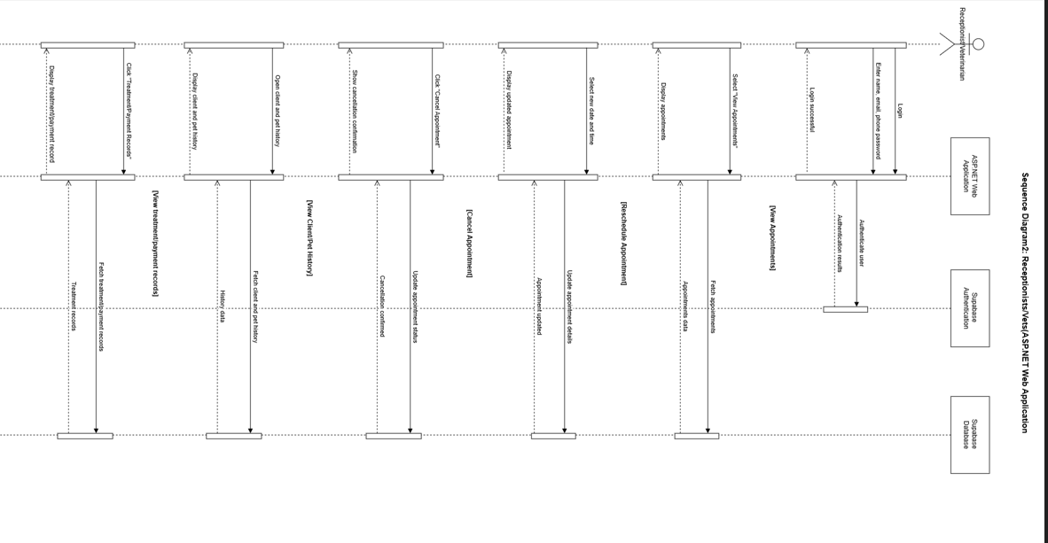
Figure 4: ASP.NET Sequence Diagram
This sequence diagram illustrates how receptionists and veterinarians interact with the ASP.NET web application to log in, view appointments, reschedule or cancel appointments, view client and pet history, and access treatment and payment records. The application communicates with Supabase Authentication for login and the Supabase Database to retrieve and update the relevant information.

- Database Design
Entity Relationship Diagram (ERD)
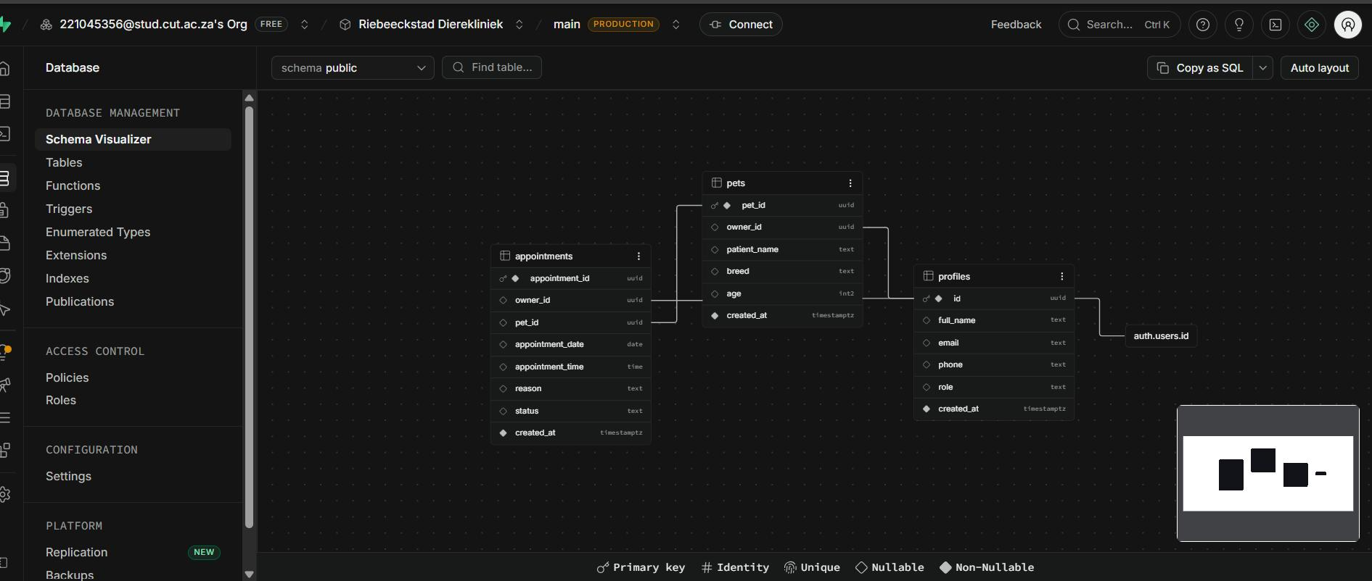
Figure 5: ERD
The ERD consists of three main tables: profiles, pets, and appointments. The profiles table stores user information such as their name, email, phone number, and role, and is linked to Supabase Authentication. One profile can have many pets, and one profile can also have many appointments. Each appointment is linked to a specific pet using the pet ID, while storing the appointment date, time, reason, and status. This allows the system to connect the client, their pet, and their appointment information in one database.

- User Interface Design

Flutter Mobile Screens
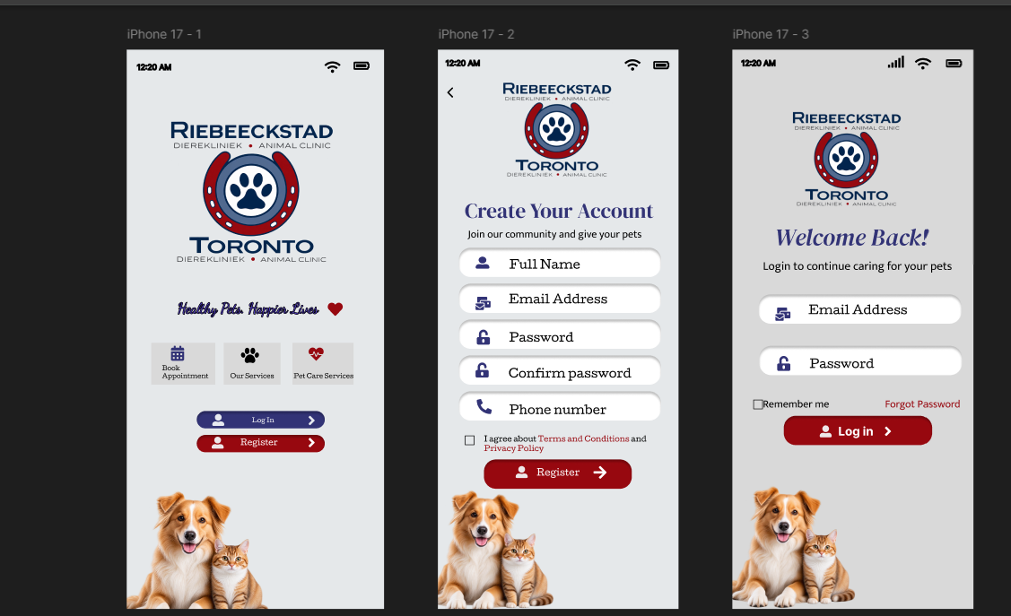
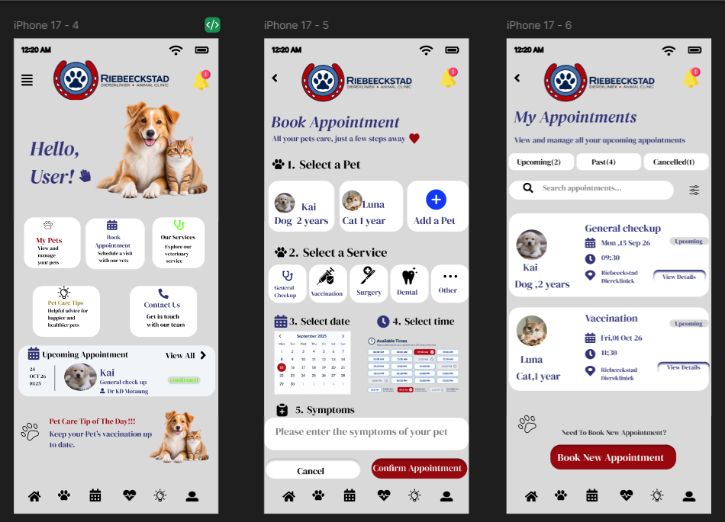
Figure 6.1-6.3: Flutter Mobile Screens

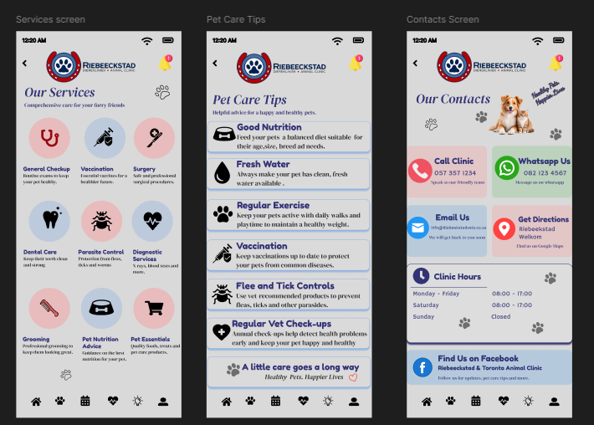

ASP.NET Web Page Screens

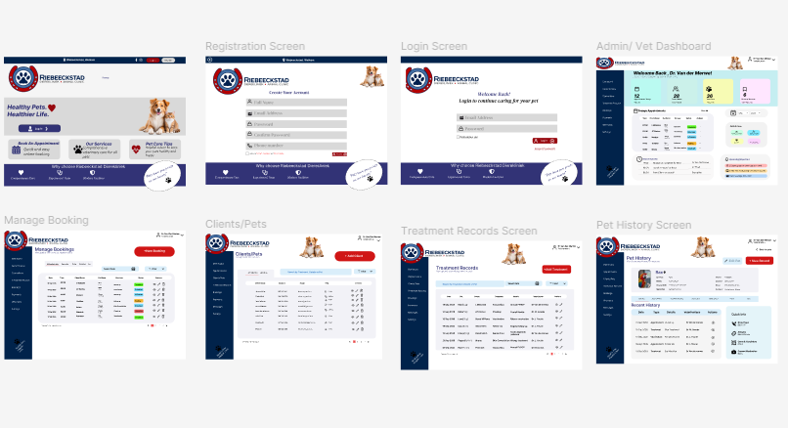

Microsoft Project screenshot

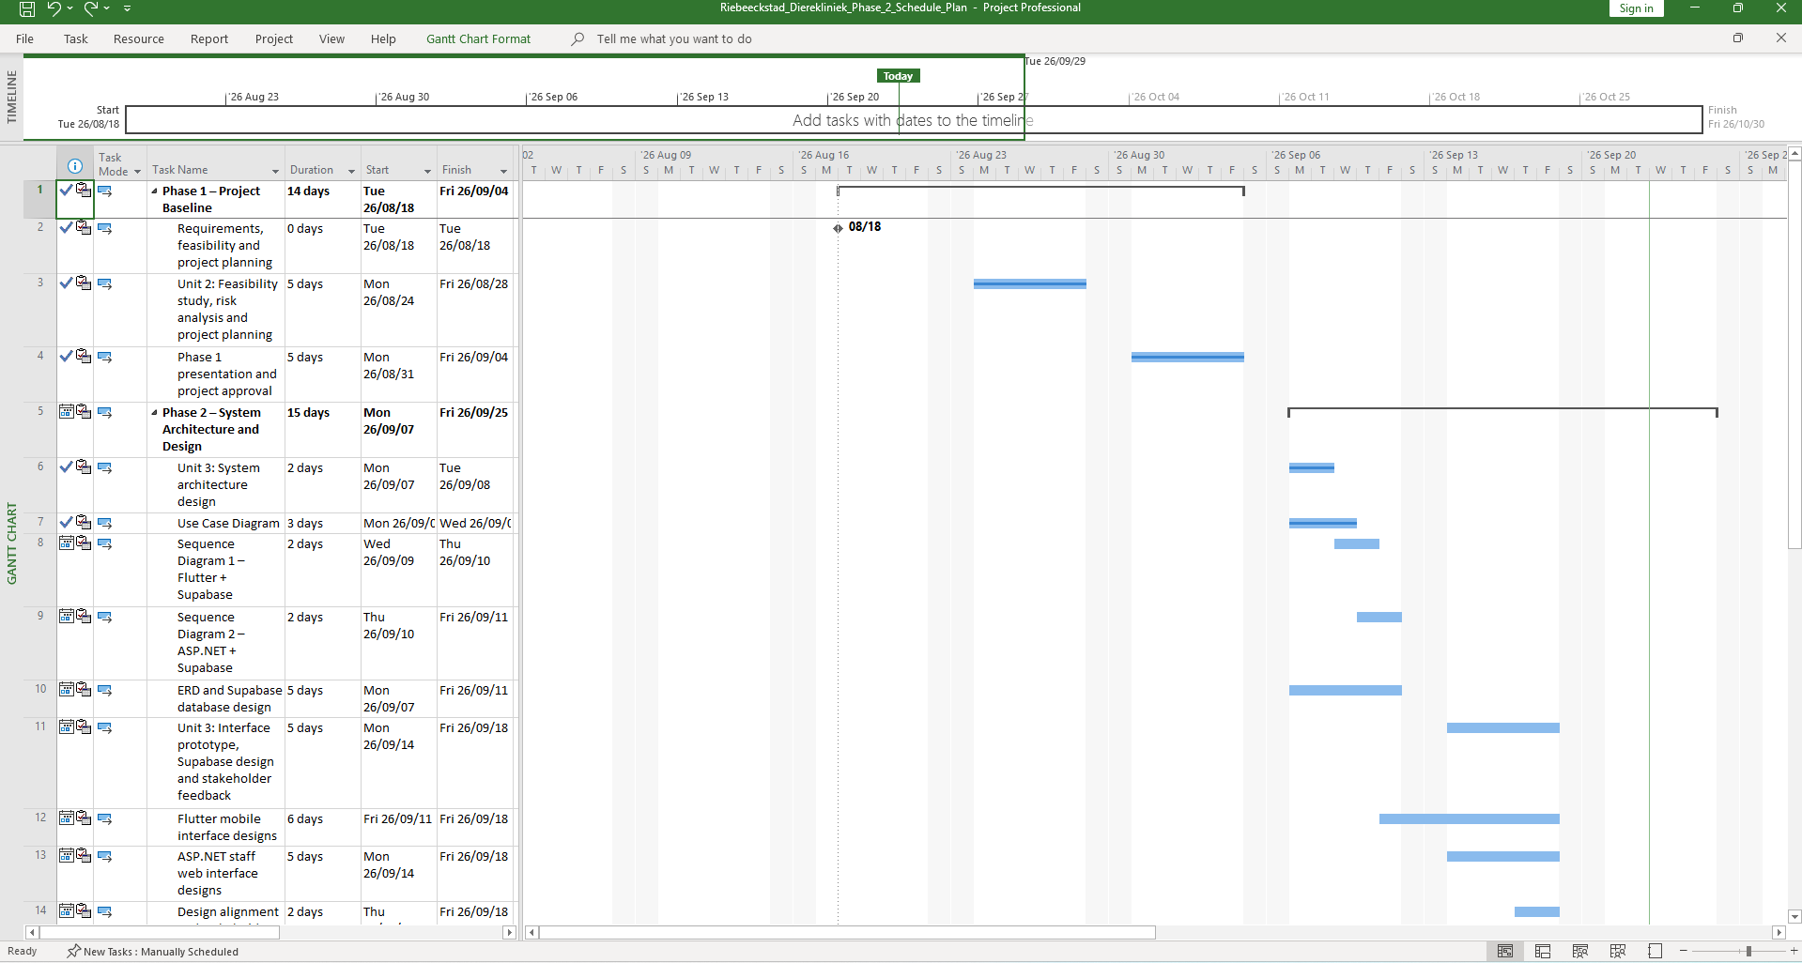

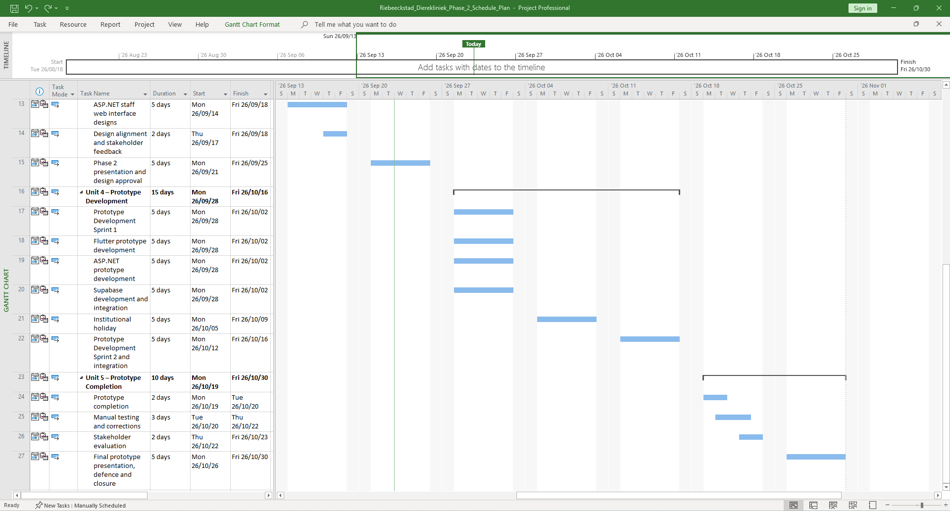
Design Source Links
Name | Tool Used | Source Link
System architecture diagram | Draw.io | https://drive.google.com/file/d/1LEWTZiz6sWylR_XslPZo1JKkwtjRFu-E/view?usp=sharing
ERD | Supabase | https://supabase.com/dashboard/project/qgzrolkkggcmfxoycadj/database/schemas
Figma Wireframe | Figma | https://www.figma.com/design/jP4MefpntE53Wr4prUKgd7/ASP.NET?t=fVxVhwrB32KYHaYA-0  https://www.figma.com/design/lNBlaus1u17yPdTWfaloDe/Flutter-Mobile-Application?node-id=0-1&p=f&t=fVxVhwrB32KYHaYA-0
Use Case Diagram | Draw.io | https://drive.google.com/file/d/1wY9Z1cAvOy_1QSWmCmXRsKA_Dw9jqXqA/view?usp=sharing
Sequence Diagrams | Draw.io | https://drive.google.com/file/d/1wBS9P0cflFIfbxg3DXmpL680Jk-80DZv/view?usp=sharing  https://drive.google.com/file/d/1gNzSsPDkSKZodsdLiFaK1ueex8D_RC2r/view?usp=drive_link

- GitHub: https://github.com/Tseko024/Riebeeckstad_Dierekliniek-.git
- Supabase: https://qgzrolkkggcmfxoycadj.supabase.co/rest/v1/

